ITEC 3200 SQL Homework Assignment, Part 2

Instructions: Use the Fitness database and MySQL to write an SQL script using DML statements. Make sure to number the questions (HW1, HW2, etc.) and that they are IN ORDER. Save in one SQL script, named Homework2.
Go to Edit | Preferences | SQL Editor, and un-check “Safe Updates”.
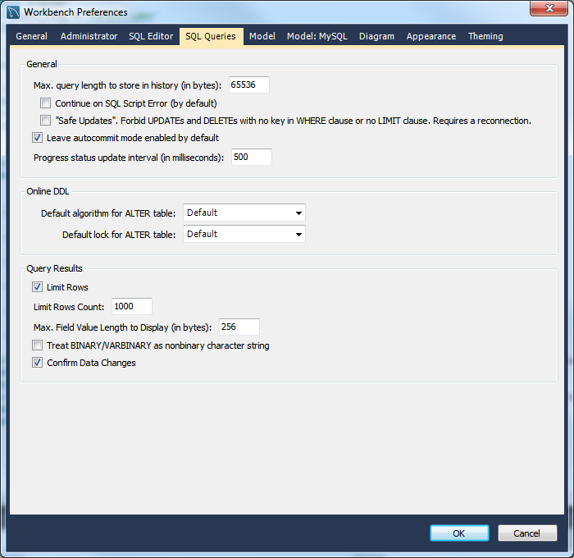
Then click the Reconnect to DBMS button (the last button just under the File menu.) 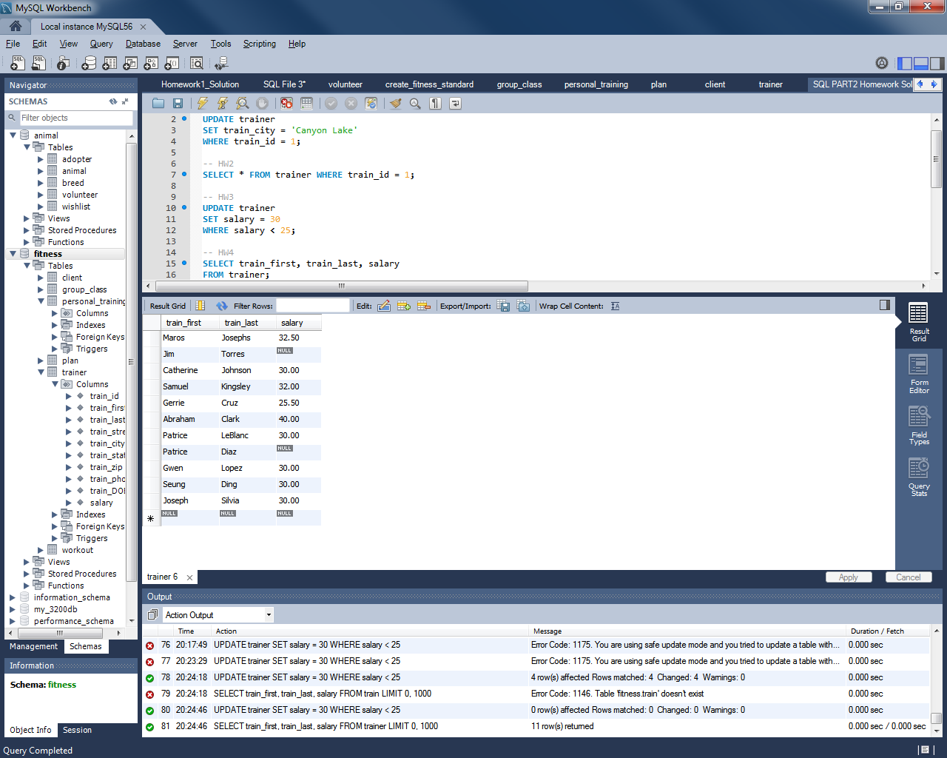
Here are the questions:
- Change the city of the trainer having ID = 1 to Canyon Lake.
- To verify that the change has been made, select all fields from trainer for train_id = 1.
- Make changes to the database so that all trainers making less than $25 an hour will be making $30 an hour.
- To verify that the change has been made, select all trainers’ name and salary from the trainer table.
- The Fitness gym has decided to carry a new group class. Add this to the Group_class table:
Group_id: 50 className: Zumba calories_burned: 600
- To verify that the change has been made, select all records from the group_class table.
- Insert a new client into the Client table. You may use yourself or make up a client.
- To verify that the change has been made, select all fields for this new record.
- Write and run the SQL that will delete the new record from the client table.
- Run the query from question (8) again. This time there should be no rows returned. That is, all NULL values.
- Using the UNION SQL statement, create a query that lists the Client’s first and last name, city state zip, along with the same information for all of the trainers. Indicate whether the person is a client or a trainer. Format the names as LAST, FIRST, and order by last name as shown in the results below: (only the first few rows are shown.) You will actually have 22 rows. Name the columns as shown.
